Problem Statement

**IBM-Project-27159-1660048023**

**[Type the company name]**



Submitted by:

* Vigneshwaran M (Team Leader)
* Karthikeyan M
* Vishnu Chidambaram R
* Mathew akash P

Skill / Job Recommender Application

**SKILL / JOB RECOMMENDER APPLICATION**

**PROBLEM DESCRIPTION:**

* To develop an end-to-end web application capable of displaying the current job openings based on the user skillset.
* The user and their information are stored in the Database.
* An alert is sent when there is an opening based on the user skillset.
* Users will interact with the chatbot and can get the recommendations based on their skills.
* We can use a job search API to get the current job openings in the market which will fetch the data directly from the webpage.

**TECHNICAL ARCHITECTURE:**

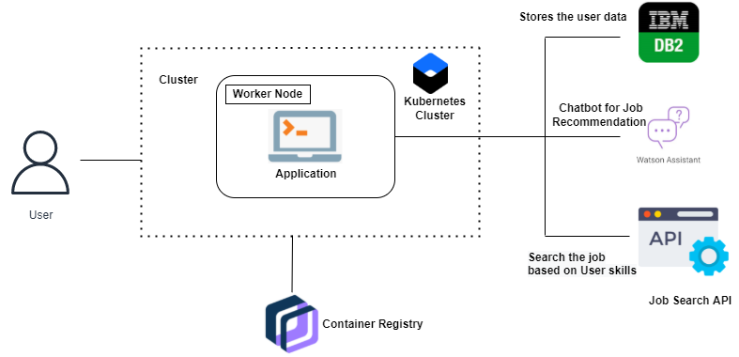

**TECHNICAL STACK:**

* IBM Cloud
* Html
* Javascript
* IBM Cloud Object Storage
* Python-Flask
* Kubernetes
* Docker
* IBM DB2